8th Grade keyboard elective
Marine View Middle School 2013

This class is designed to give students exposure to the Grade 8 California Music Standards, specifically in the area of piano study. Within this class, students will learn the art of playing an incredible instrument: the piano. Our studies will include knowledge in respect to technique, theory, ear training, and performance.

Week One/Two/Three: “Read It” - A Study in Notation and Rhythm
1.2 Read, write, and perform rhythmic and melodic notation in duple, triple, compound, and mixed meters.
- Curriculum: Finger Numbers, Treble/Bass Clef Note Reading, Rhythmic Note Values, C Position/Middle C Position
- Activities: C Major Scale, “Ode To Joy”, “Happy Song”, Lines and Spaces Test

Week Four/Five/Six: “Change It” - A Study in Accidentals
1.1 Read, write, and perform augmented and diminished intervals
- Curriculum: Sharps vs. Flats, Incomplete Measures, Key Signatures, G Position
- Activities: G Major Scale, “Jingle Bells”, “Good King Wenceslas”, “Willie and Tillie”, Rhythm Test

Week Seven/Eight/Nine: “Feel It” - A Study in Expressive Devices
1.4 Sight read music accurately and expressively
- Curriculum: Dynamics, Tempos, Harmonic vs. Melodic Intervals, D Position
- Activities: D Major Scale, “Cuckoo”, “Money Can’t Buy Everything”, “Indian Song”, Expressive Device Test

Week Ten/Eleven/Twelve: “Perform It” - A Culminating Study
2.3 Perform on an instrument a repertoire of instrumental literature with expression, technical accuracy, and articulation.
- Curriculum: Ear Training, Pop Charts, Culminating Review
- Activities: Jeopardy, “Grandpa’s Clock”, “Happy Birthday”, Final Song
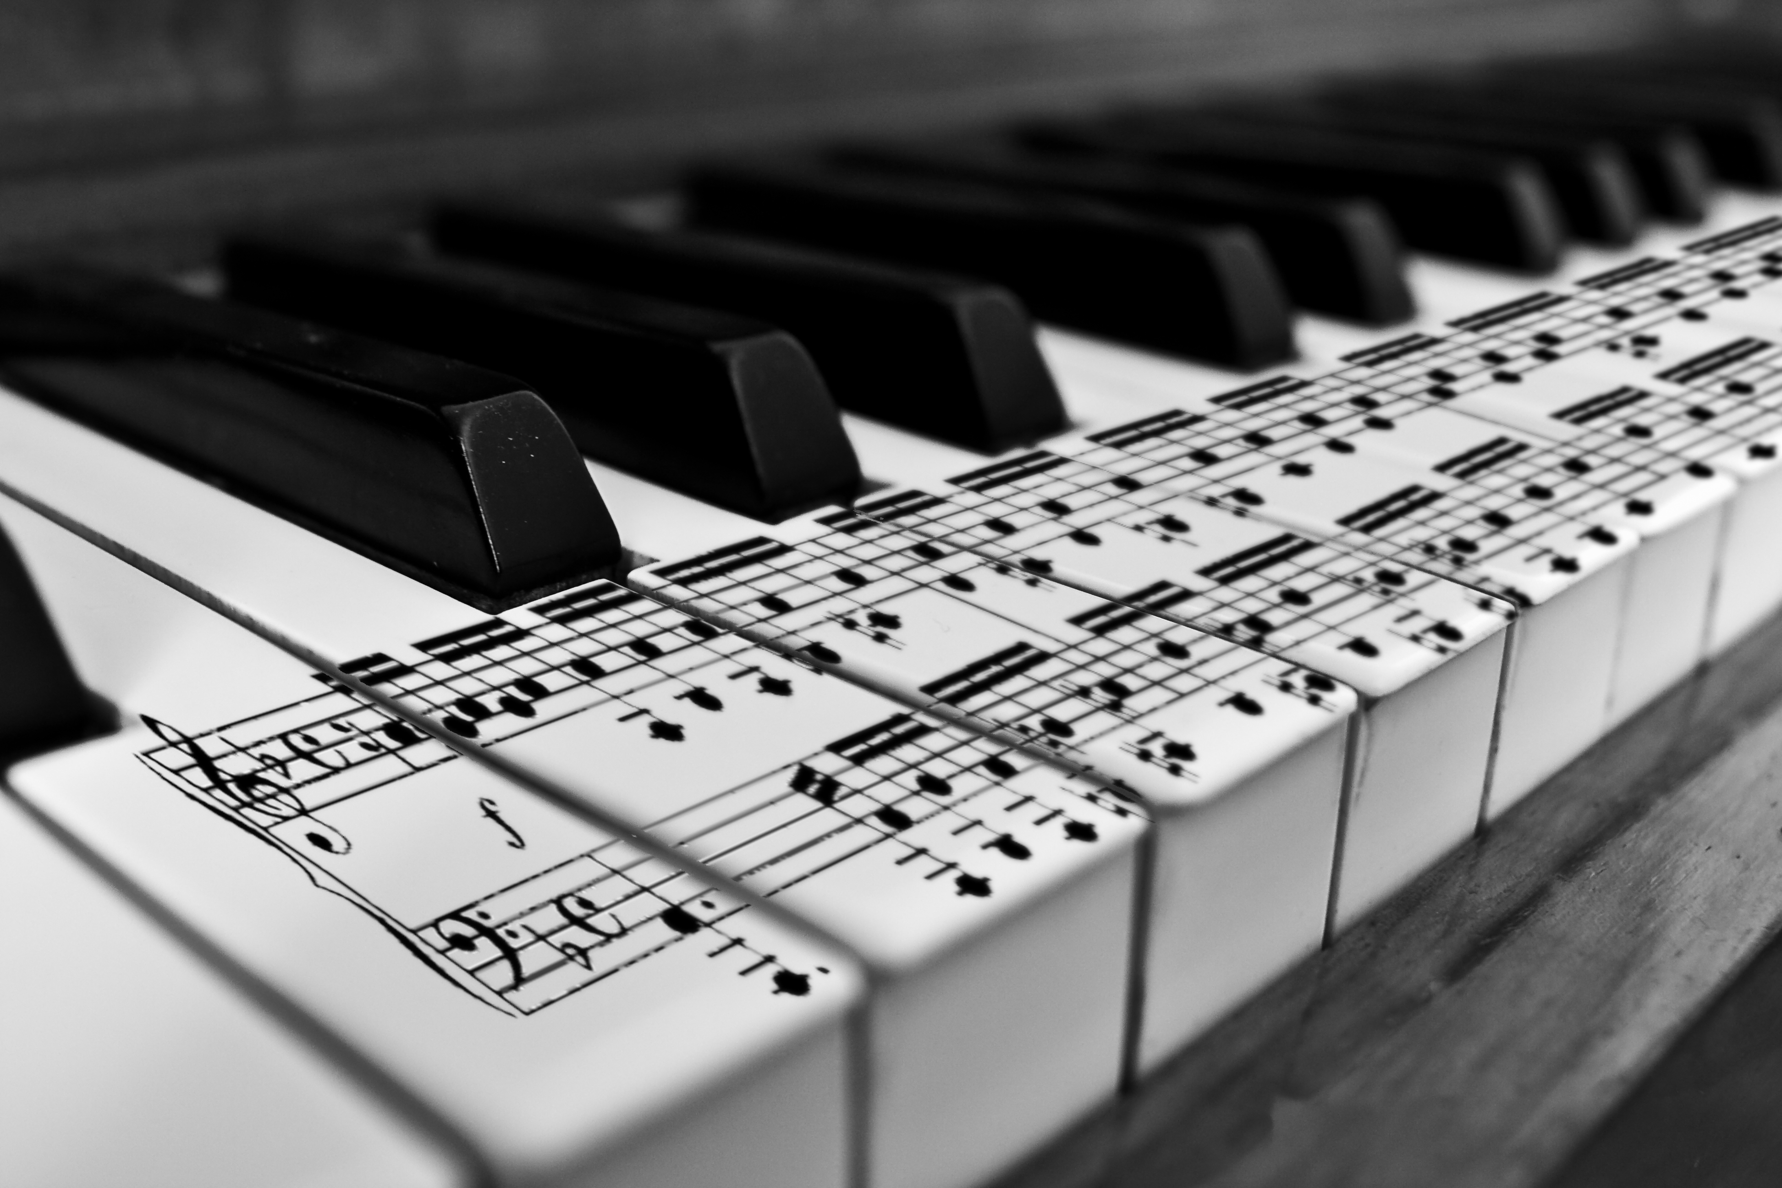
WELCOME TO 8TH GRADE KEYBOARD!
Instructor – Ms. Gomez – Period 3

Welcome to 8th Grade Keyboard! I’m looking forward to this upcoming trimester of our new elective class. We will be studying the art of playing piano along with gaining a basic understanding of music theory and technique; this will include note values, note names, expressive devices, and much more. You will have the opportunity to put the music theory you’ve learned to practice by playing a variety of songs from varying genres on the piano! Students will be graded on the following:

- Daily Participation = 40% of total grade

- Testing (written and performance) = 40% of total grade

- Keyboard Binder = 20% of total grade

Classroom Expectations:
- Follow directions the first time given
- Be respectful and courteous to yourself and others
- Come to class ready to learn and do your personal best!
- Keep hands and feet to yourself
Classroom Procedure:
- If absent, you will be expected to ask me what you missed.
- If late, you should come in quietly, do not disrupt the class. You will be marked tardy.
- The class period starts when the bell rings and ends when I dismiss you.
- You should come to class prepared to learn.

Please sign and return the bottom portion of this letter signifying that you’ve received and understand the class policies and expectations. I am greatly looking forward to an exciting trimester with you! If you have any questions please feel free to call or message me at (714) 846-0624 x2630 or egomez@ovsd.org.
Sincerely,
Ms. Elise Gomez

Student Signature Parent Signature

